QR Code-Based Inventory Management System

1. Components and Their Roles
(a) Raspberry Pi 4B (4GB RAM)
- Role: Main processing unit for QR code scanning, data processing, and integration with Google Sheets.
- Why Used?: Runs Python scripts and supports USB peripherals.
(b) MH-ET LIVE Scanner (QR Code Scanner)
- Role: Reads QR codes and sends data to Raspberry Pi.
- Why Used?: Outputs data via USB (keyboard emulation) or I2C communication.
(c) SD Card (at least 16GB recommended)
- Role: Stores Raspberry Pi OS, Python scripts, and dependencies.
(d) Power Cable
- Role: Provides power to Raspberry Pi.
- Why Used?: Requires 5V, 3A USB-C power supply.
(e) Jumper Wires (Male-Female)
- Role: Connects Raspberry Pi and other components (if I2C is used).
(f) Resistors (4.7kΩ x2)
- Role: Used for pull-up resistors in I2C communication.

2. Hardware Connections
Method 1: USB Connection (Preferred)
- Plug the MH-ET LIVE scanner into any USB port on the Raspberry Pi.
- Acts like a keyboard, inputting scanned QR codes as text.
Method 2: I2C Connection (Alternative)
QR Scanner Pin | Raspberry Pi GPIO Pin
SDA | GPIO 2 (Pin 3)
SCL | GPIO 3 (Pin 5)
GND | GND (Pin 6)
VCC (5V) | 5V (Pin 2)
Enable I2C on Raspberry Pi:

# Navigate to Interfacing Options -> Enable I2C

3. Software Implementation
Step 1: Setting Up the Raspberry Pi
- Install Raspberry Pi OS.
- Enable I2C in Raspberry Pi settings (raspi-config).
- Install required packages:
- sudo apt update && sudo apt install python3-pip i2c-tools
Step 2: Installing Python Libraries
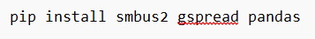

- smbus2: For I2C communication.
- gspread: For Google Sheets integration.
- pandas: For data handling.
Step 3: Reading QR Code Data via I2C
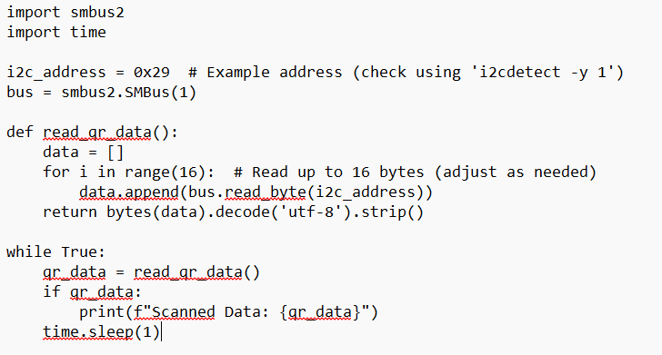

4. Google Sheets Integration
Step 1: Enable Google Sheets API
- Enable Google Sheets API in Google Cloud Console.
- Create a service account and download the credentials JSON file.
- Share the Google Sheet with the service account email.
Step 2: Python Script to Update Google Sheets
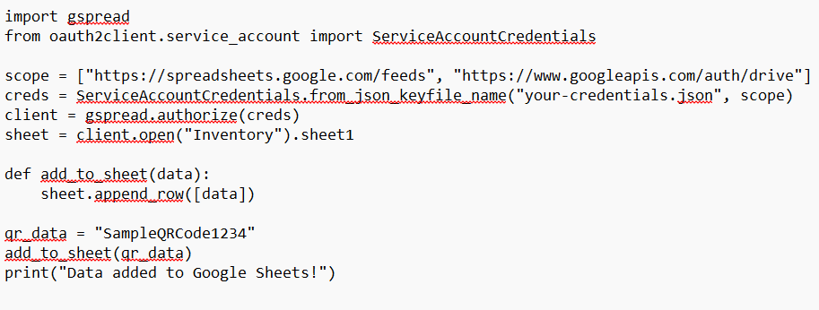

5. Categorizing Inventory Items
Google Sheets Structure
QR Code | Item Name | Date & Time | Stock Quantity
ABC123 | Mouse | 2025-02-26 14:30 | 10
XYZ456 | Keyboard | 2025-02-26 14:35 | 5
Updated Python Script for Categorization
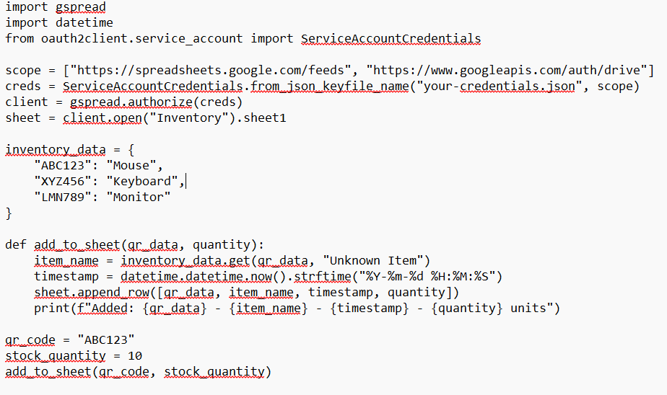

6. Final Project Workflow
- Power on Raspberry Pi.
- Run the QR scanner script (USB or I2C method).
- Scan a QR code.
- Extract data and send it to Google Sheets.
- Verify inventory update in Google Sheets.

